Egypt PDPL Compliance for Log360
Strengthen data protection and meet Egypt PDPL compliance with Log360.
Region: Egypt | Type: Data Privacy | Category: Compliance | Pricing: Free

Overview
The Egypt PDPL compliance extension in Log360 helps organizations meet Egypt's Personal Data Protection Law No. 151/2020, enforced by the Center for the Protection of Personal Data (CPPD) by providing centralized log management, real-time breach detection, and compliance-focused audit reporting. The platform supports Egypt PDPL requirements for access control, 72-hour breach notification, processing activity records, data protection impact assessments, cross-border transfer monitoring, data subject rights, processor oversight, and data retention across cloud and on-premise environments.
For Article 4 — Technical and Organizational Security, Log360 monitors access events, system changes, and security configurations across AD, Windows, and network devices to demonstrate security measures. To address Article 6 — Access Control for Personal Data, the platform monitors AD user management, group membership changes, logon activity, and privileged access to verify that only authorized users access personal data systems. The extension also supports Article 7 — Personal Data Breach Notification by providing capabilities that provides real-time threat detection, alerting, and incident forensics to identify breaches and generate regulatory notification documentation.

Key Features
- Article 7 — Breach Incident Documentation: Log360 maintains comprehensive audit logs with timestamps, event details, and user identities providing forensic documentation for breach investigations.
- Article 10 — Data Protection Impact Assessment: Log360 monitors security controls, access patterns, and threat indicators providing the data foundation for risk evaluation and ongoing DPIA evidence.
- Article 14 — Cross-Border Data Transfer Controls: Log360 monitors network traffic, cloud service access, and data movement events to detect and log cross-border data transfers for regulatory audit compliance.
- Article 4 — Processing Activity Records: Log360 collects comprehensive audit logs from all data processing systems providing a centralized record of processing activities.


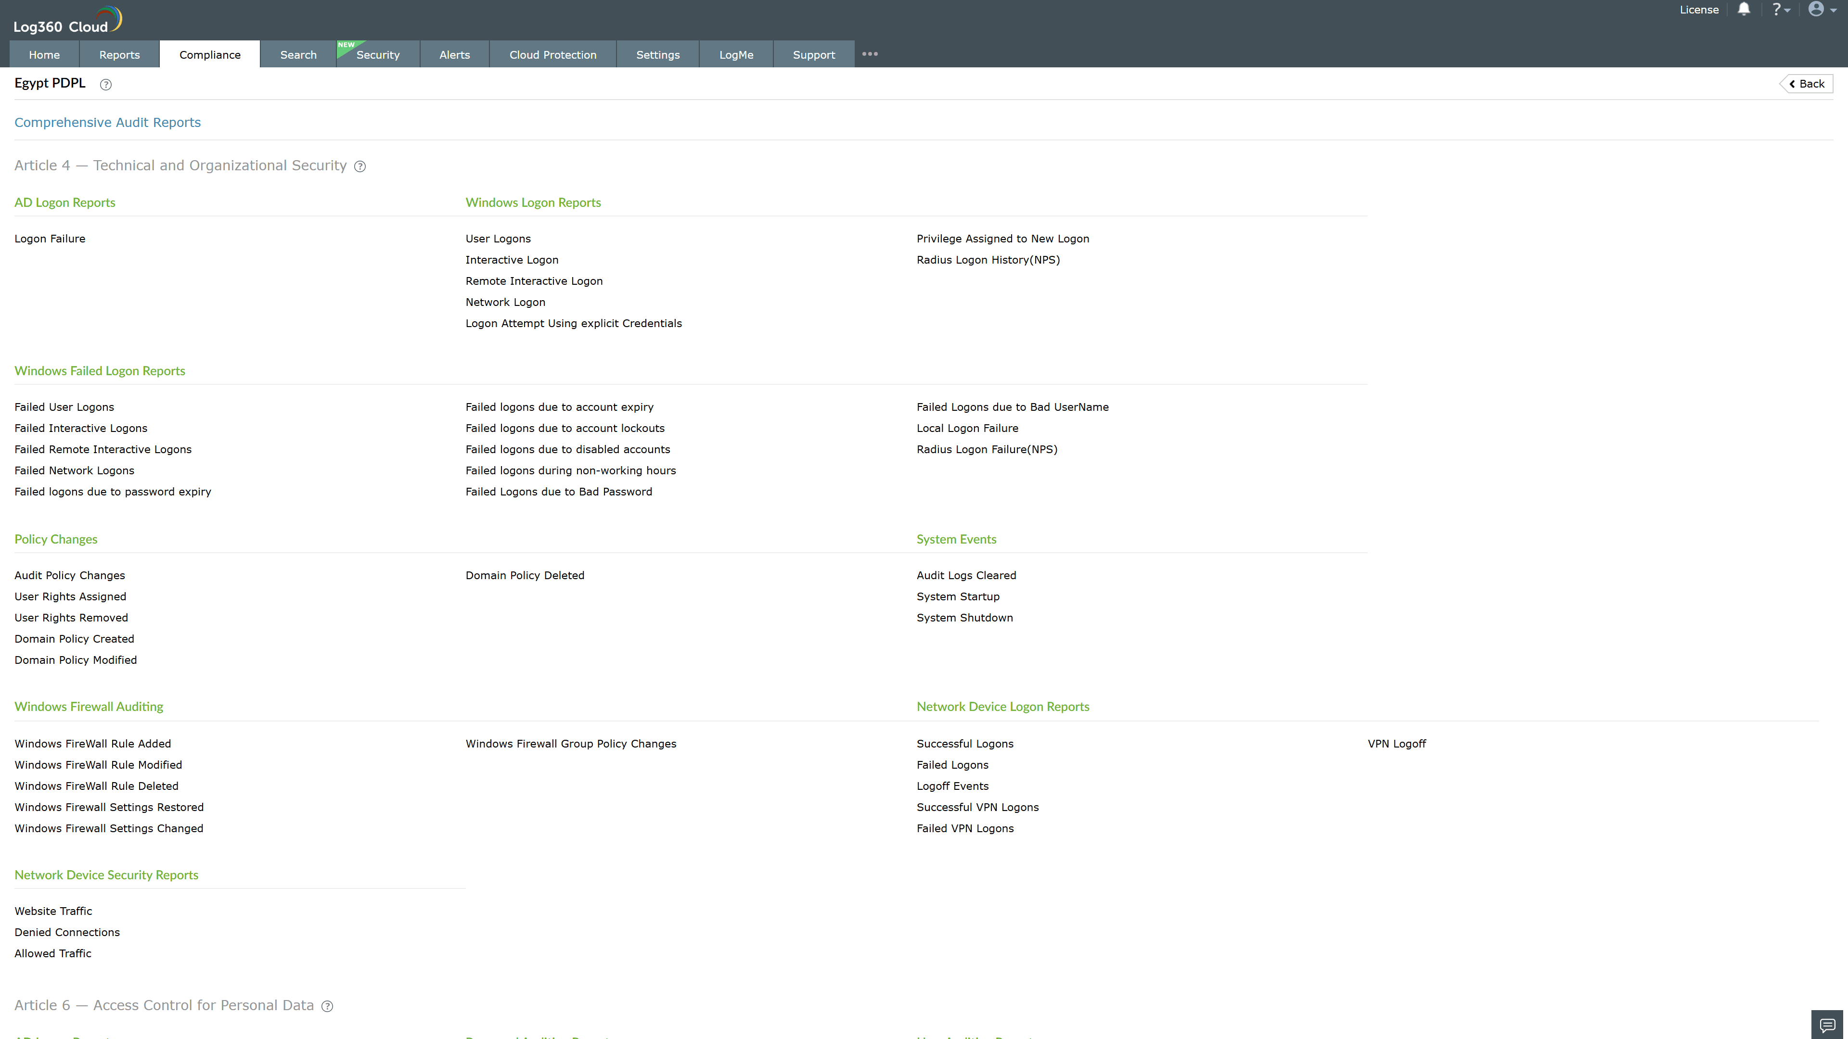
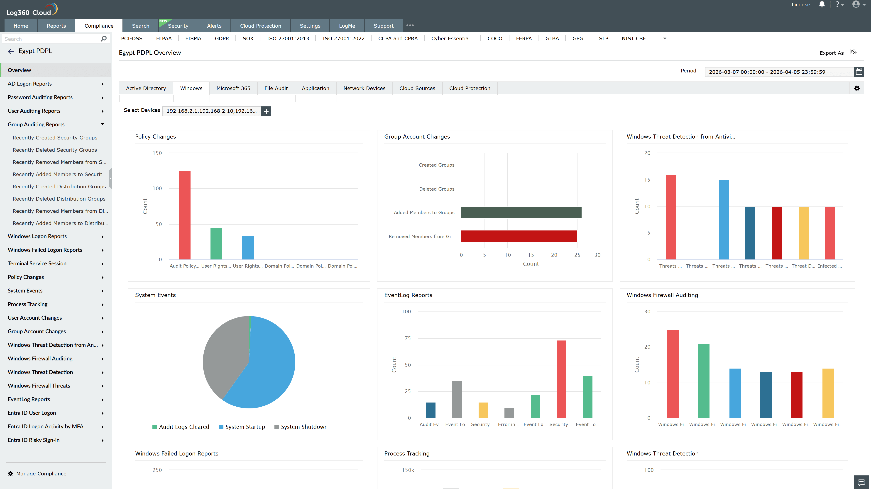
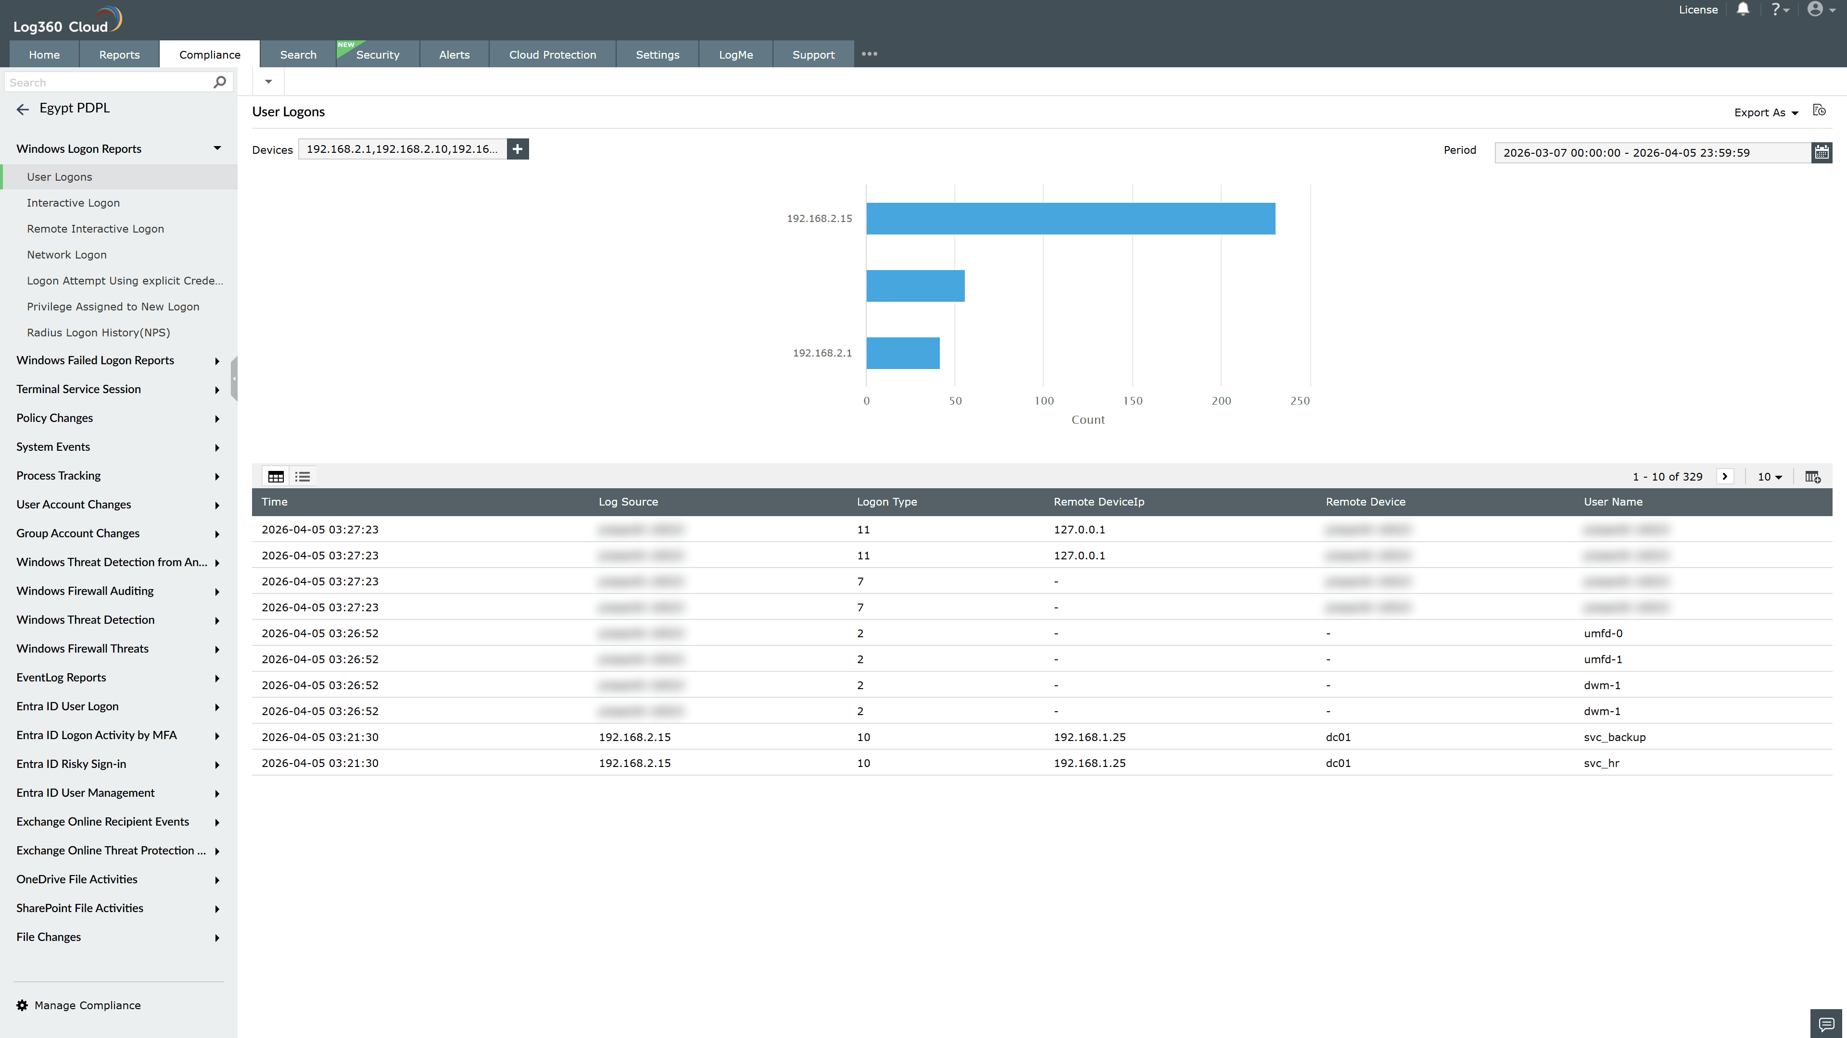
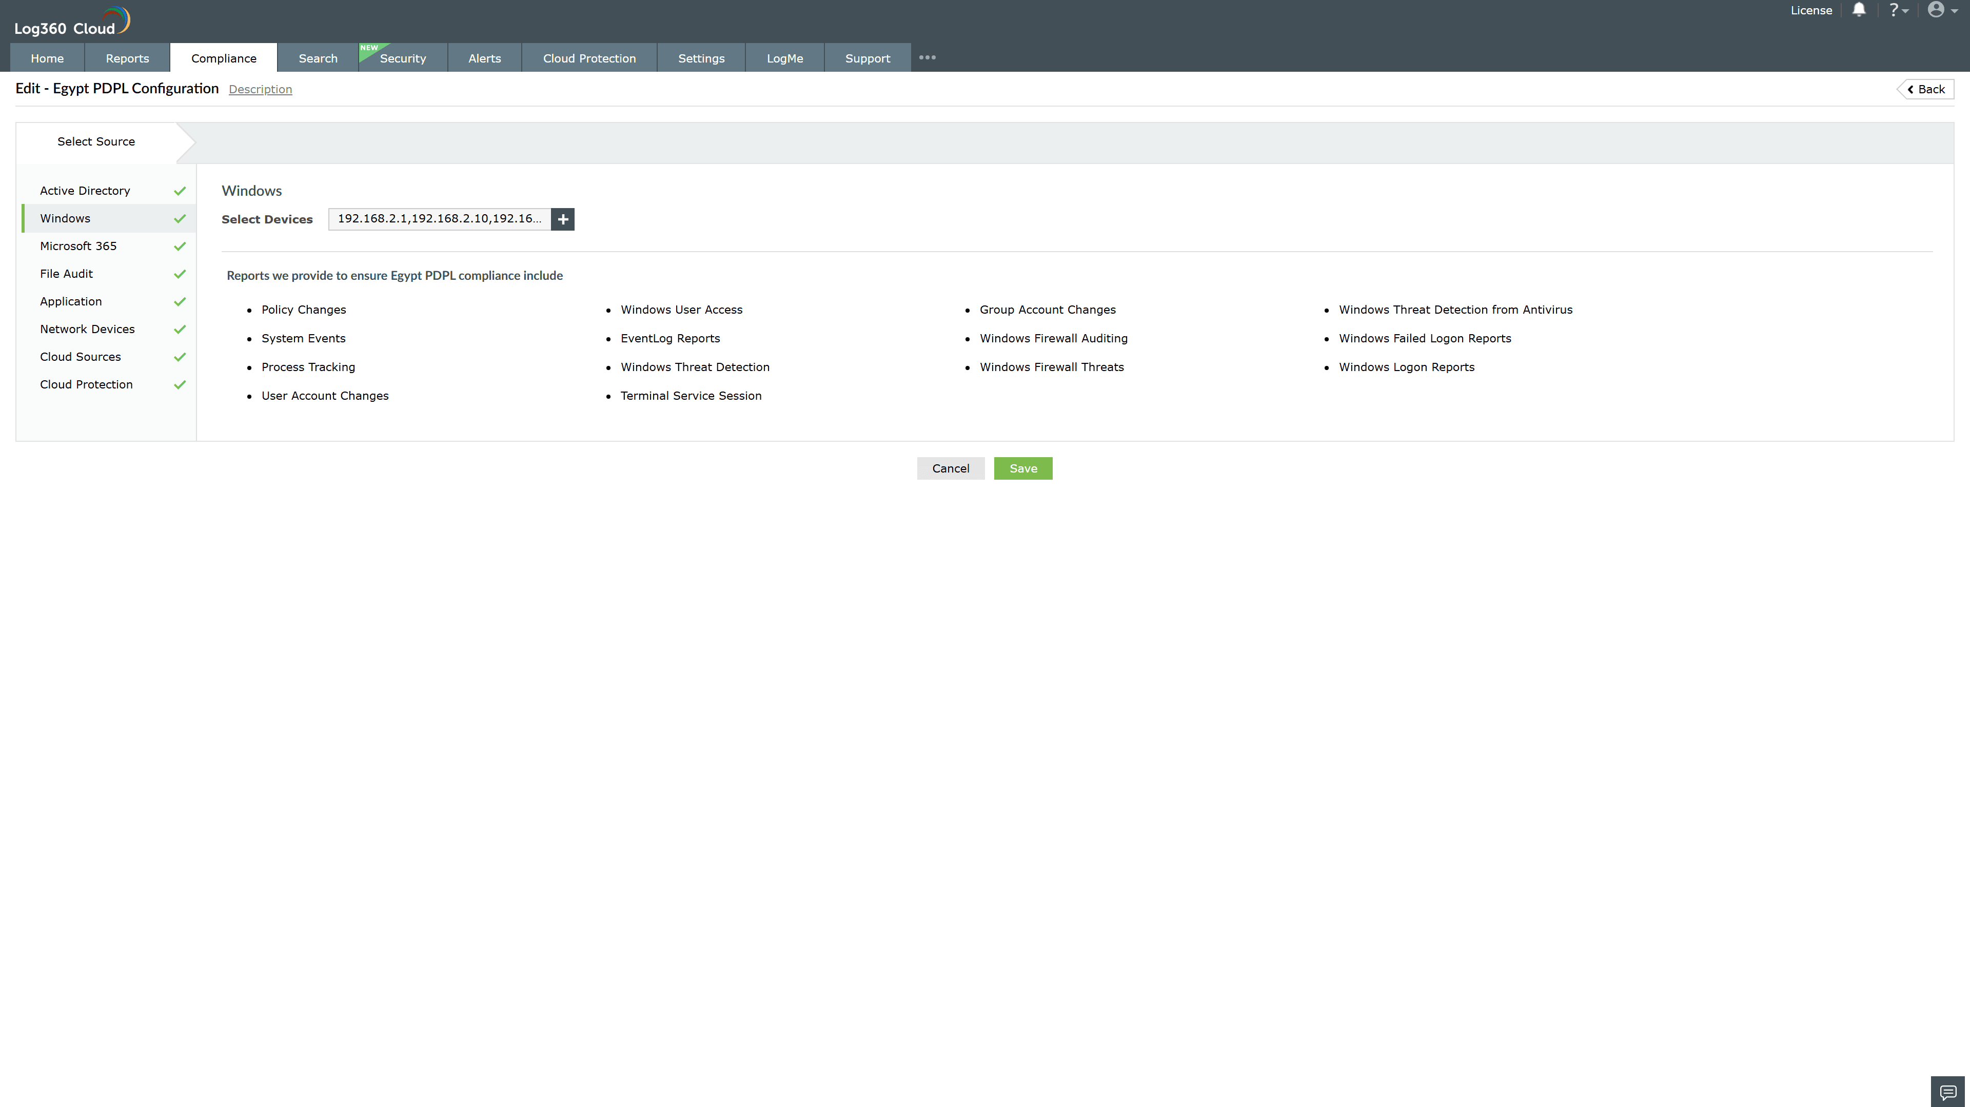
Valid Submission : Yes
Supported Editions : Free, Basic, Standard, Professional, MSSP
Help Document : https://www.manageengine.com/log-management/help/integrations/compliance-extensions.html
Help Video : Not provided
Tags : Log360, Compliance, Privacy monitoring, Data privacy, Regulatory compliance
Supported DCs : US, IN, JP, CA, AU, UK and EU
Privacy Policy:
Terms of Service:
Release Notes:
Predefined reports for the Egypt PDPL.

